4th Annual
PFC MATTHEW K. GUYON
GOLF TOURNAMENT
Thursday, May 16th, 2024
Registration 7am – Tee Off at 8a
Bay Forest Golf Course
201 Bay Forest D, La Porte
Golf Tournament limited to 144 players.
TITLE SPONSOR - $4,000
Contact:
John Guyon
713.301.8360
pfcmkg@gmail.com
3 Four Man Teams • 1 Tent on the course • 4 Hole Signs • Sponsor Plaque • Logo on Banner

PLATINUM SPONSOR - $2,500
2 Four Man Teams • 1 Tent on the course
• 3 Hole Signs • Logo on Banner
Mail Payments To:
PFC Matthew K Guyon Foundation
PO Box 1796
La Porte, TX 77572

GOLD SPONSOR - $1,500
1 Four Man Teams • 1 Tent on the course
• 2 Hole Signs • Logo on Banner
SILVER SPONSOR - $800
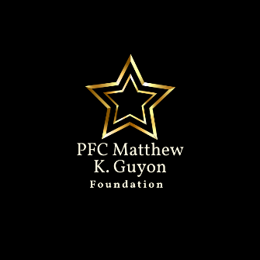
1 Four Man Teams • 2 Hole Signs
• Logo on Banner
SPONSORSHIPS:
__ One Foursome - $600 PLAYERS
__ Tent Sponsor - $400 _______________________
__ Hole Sponsor - $200 (2 Signs) _______________________
__ Donate Door Prize(s) _______________________
__ Swag Bag Donation – 160 items _______________________
__ Individual Golfer - $150

PLEASE PRINT LEGIBLY
Company Name: ________________________ Email: ____________________________
Contact: ________________________________ Phone #: __________________________
Address: _______________________________
City: ______________ State: ____ Zip: ______

